CRAILING, ECKFORD AND NISBET COMMUNITY COUNCIL
2024-2027
Minutes of General Meeting No 12
7-9pm 22nd June 2026 Lothian Hall, Crailing
Chair Charlie Robertson
No |  | ITEM | ACTION
1 |  | CR welcomed everyone to the Meeting.
2 |  | Attendance  Keith Bader KB, Virginia Burbridge VB, Richard Howes RH Katherine Pery KP, Charlie Robertson CR,  In Attendance Councillor John Bathgate JB,  Emma Donnelly, Member of the Public  In accordance with the SBC Scheme for Community Councils, Emma’s name had been advertised on an agenda, and a nomination form had been completed. Emma was therefore co-opted on to our CC. She was very warmly welcomed. CR will forward the form to SBC | CR
3 |  | Apologies  Councillors Scott Hamilton SH, & Sandy Scott SS  PC Carin Tait-Logan CTL, Community Police Officer
4 |  | Approval of Minutes of the Meeting of 11th May 2026. Proposed KP Seconded KB
5 |  | Matters Arising (not covered in the Agenda)  Nil
6 |  | Treasurer’s Report (Appendix 1) Report submitted, discussed & approved. Accounts looking quite healthy. Defibrillator situation looking much healthier. However, we need to seek funding now for our spending commitments in 2026/7 | ALL
7 | Community Updates  1 SBC Councillors  LiveBorders. Making steady progress. Plans to reinvigorate the Teviotdale Leisure Centre and Tweedbank Athletics Stadium and to convert Tweedbank Bowling Centre into a Gymnastic Centre.  Jed Swimming Pool. Business Plan goes before the Council this week. New Trustees in place. Reopening early next year.  Old Jed Grammar. Travellers back again and moved on. Main building to be preserved. Other buildings for sale or maybe demolished and the site for sale for houses. Maybe sheltered housing.  Proposed windfarm at Ditcher Law, Lauder. Council objections upheld by Scottish Government  Parking. Other than the existing ones, no other Car Parks will charge fees.  Cycling. Tour of Britian stage starts and ends in Earlston. Tour de France coming through the Borders next year. Both to make a big contribution to the Borders economy.  Special Visitor. Coming to Jed.  Concerns were raised about the proposed Data Centre in the Lammermuirs and the Council’s Policy towards it. How many more would come to the Borders?  Disappointment was expressed that the Council were to stop funding the Christmas Trees for Border Towns. Jed CC to fund their tree.  2 Crailing  - Crailing Rideout. Both visits organised and the Piper booked. CR to be present at both. Details had been circulated on Crailing WhatsApp Group.  - Crailing Residents had contacted CR concerning the state on the Noticeboard. CR to contact UPW, who did the original work, to arrange repairs.  - 3. Eckford  - Grahamslaw Road. Still needing work done to shore up the sides.  - Potato Boxes at Wester Wooden. Pile considerably reduced  - Septic Tank Wester Wooden Cottages. Concern had been expressed about the septic tank that services Nos 5,6,7 & 8 Wester Wooden Cottages. The lid of the tank is cracked and there have been complaints about the smell emanating from it. No progress yet. Possible referral to Environmental Health.  - 4. Nisbet  - No issues to report  5. Ulston  - No report. |  | CR  CR  KB/JB  CR
8 | CENCC Ongoing Actions  i President’s Route. No progress yet.  ii Resilience No issues to report.  iii Kalemouth Bridge. No progress to report  iv Community Place Plans. SBC had been contacted to see whether some Consultancy time might be made available for this. There will then be follow-up discussions and consultations with the community.  v Defibrillators. Future funding options. A Car Boot sale at St Boswells might be a possibility. VB to follow this up.  vi Distillery Visit Still on the cards. |  | CR  CR, KB,RH  VB  CR
9 | New Business  i Callant’s Visit  See above.  ii Meeting Schedule  Agreed. (Appendix 2). CR to book Halls.  iii Code of Conduct.  Read and signed (Appendix 3) CR to forward to SBC.  iv Missing Lynx Consultation. Meeting discussed the proposals but declined the offer of a presentation. CR to complete survey response. |  | CR  CR  CR
10 | Planning Applications  i 4 Bonjedward Cottages, Replacement Window, Listed Building. CC had responded in favour
ii | AOCB  i Old Eckford Quarry. Signs of increased activity recently and a considerable amount of earth moved. Not aware of any planning application for change of use. JB to check out.  ii Lower Kale from Eckford Mill to Kalemouth. There appears to be a dearth of wildlife in the area recently. Is something keeping them away? KB to check with SEPA  iii Centre Parcs Assurances that all waste water will be thoroughly treated and cleaned before going into the Teviot. Will this be the case?  iv Old Jedburgh Library Reopening. Appeal for books – particularly Childrens Books.  These issues to be further addressed at our next meeting. |  | JB  KB
11 | DONM Meeting 13  Monday 7th September 2026 7.00-9.00  Village Hall, Eckford

Appendix 1

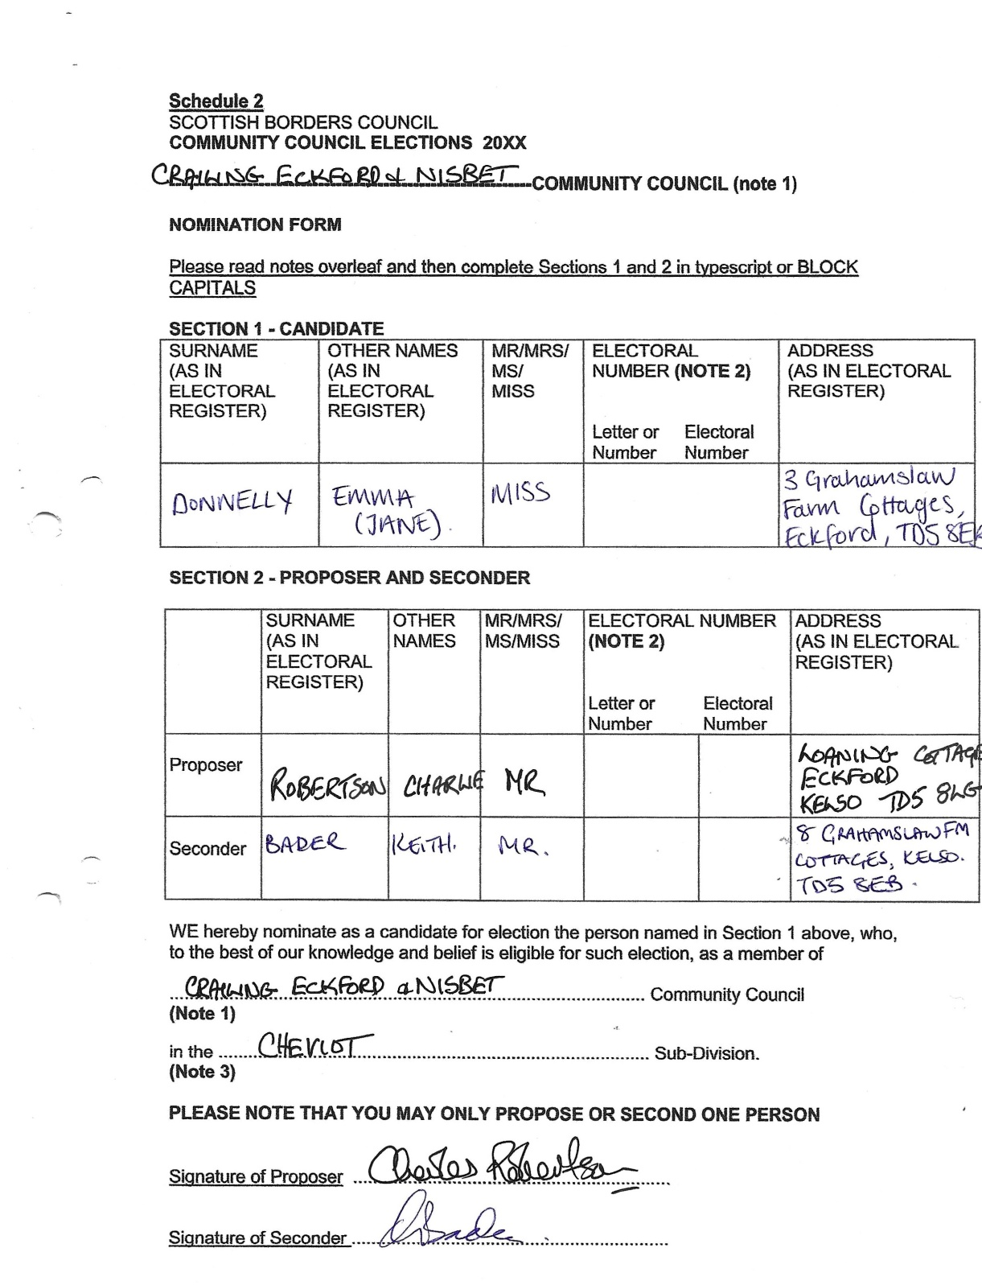

Appendix 2
Appendix 2

ACCEPTANCE OF NOMINATION
I, the nominee for election, named in Section 1 above, consent to be nominated as a candidate for the abovementioned Community Council and, if elected, will accept office as a member of the said Community Council and agree to comply with the Code of Conduct for Community Councillors.
I confirm that I have not served a prison sentence (including suspended sentence) of three months or more in the five years before the election.
Signature of Candidate
NOTES
Please insert the name of the Community Council
Please insert in the first column the distinctive number and letter if any, from the Register of Electors (e.g.) 21 A. The number will be found next to "Polling Distdct7)Please insert in the second column the elector number which can be found next to the elector’s name in the Register of Electors.
These numbers will be provided by the Returning Officer, on receipt of the nomination form. # left blank.
Where, in terms of the new Scheme for the Establishment of Community Councils, a Community Council area consists of a number of sub-divisions the name of the sub' division should be given.
QUALIFICATIONS FOR ELECTION
A person seeking election to a Community Council must be aged 16 or over and appear on the Electoral Register for the Commur@ Council area at the date of being proposed for membership of the Community Council, or provide proof of eligibility as advised by the Returning Officers, and must not have served a prison sentence (including a suspended sentence) of three months or more in the five years before the election. Each<;andidate shaH be nominated by a Proposer (who may be the candidate) and a Seconder, both being persons whose names appear in the said Electoral Register for the respective Comrnunity Council area, or subdivision of that area, where applicable.
COMPLETED NOMINATION FORMS SHOULD BE LODGED WITH
By no later than......................,.....................
- 17-

Appendix 2
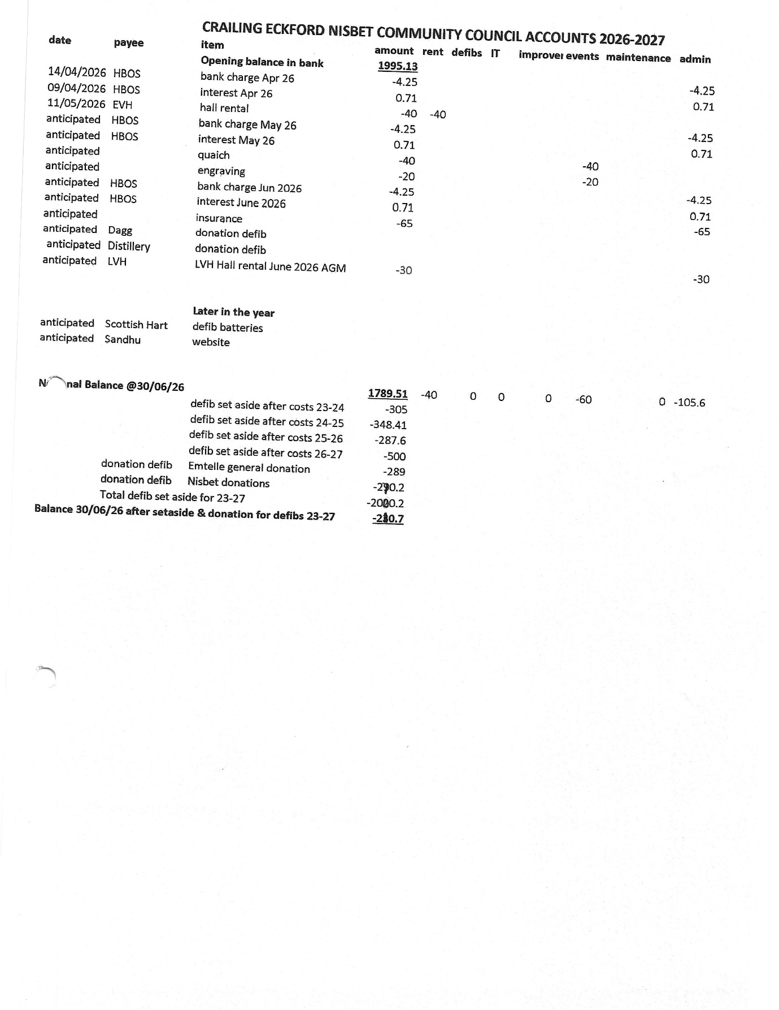

Appendix 3

CRAILING ECKFORD AND NISBET COMMUNITY COUNCIL
DATES AND VENUES
2026-2027

Monday 22ndJune General Meeting Lothian Hall, Crailing
Monday 7th September General Meeting Eckford Village Hall
Monday 9th November General Meeting Lothian Hall, Crailing
Monday 11th January General Meeting Eckford Village Hall
Monday 8thMarch General Meeting Lothian Hall, Crailing
Monday 10th May General Meeting Eckford Village Hall
Monday 14th June AGM Lothian Hall, Crailing

Appendix 4
